# How to use the app

## **Logon**

When you start the app the first time you are asked to enter credentials. First you need to logon with your Microsoft account.

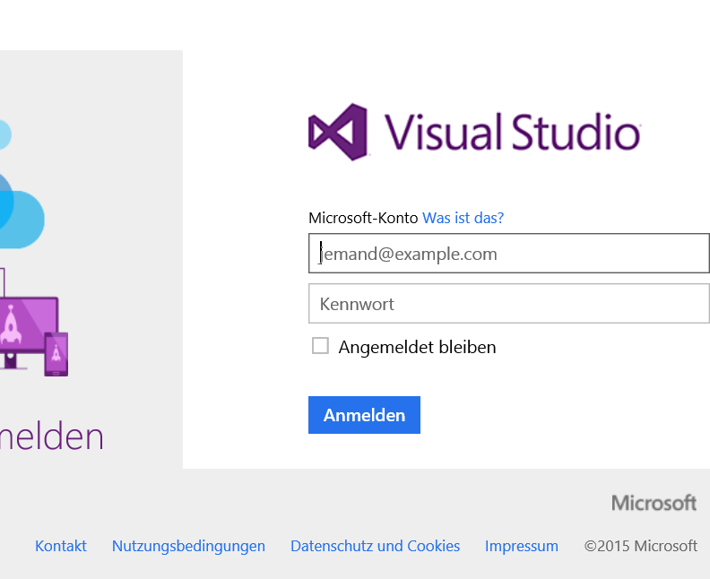

After logon you need to authorize the app. You can see in the screen which things the app is granted to. Scroll down to authorize.

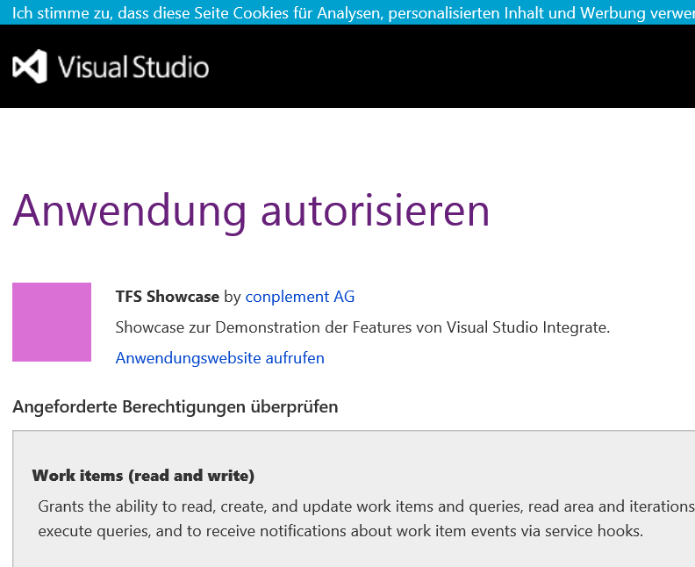

Afterwards you need to enter the alternative credentials of your VSO Account. This is needed because some information (e.g. the information on the Dashboard) will not directly be taken from VSO but by our special web service.

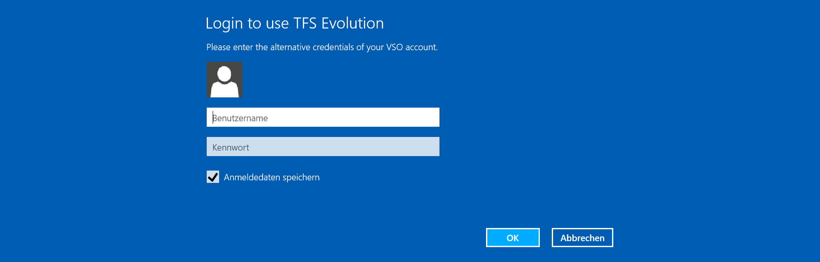

If you entered the wrong alternative credentials or you do not have access to any VSO project you will get an error. With the app settings you are able to delete the alternative credentials you entered.

Note: If you have no alternative credentials defined for your VSO account please follow this instruction <https://www.visualstudio.com/en-us/integrate/get-started/auth/overview>.

## **Select VSO Project**

After successful logon you will see all team projects from VSO you have access to. In the upper corner you will see the Microsoft account you used for login. 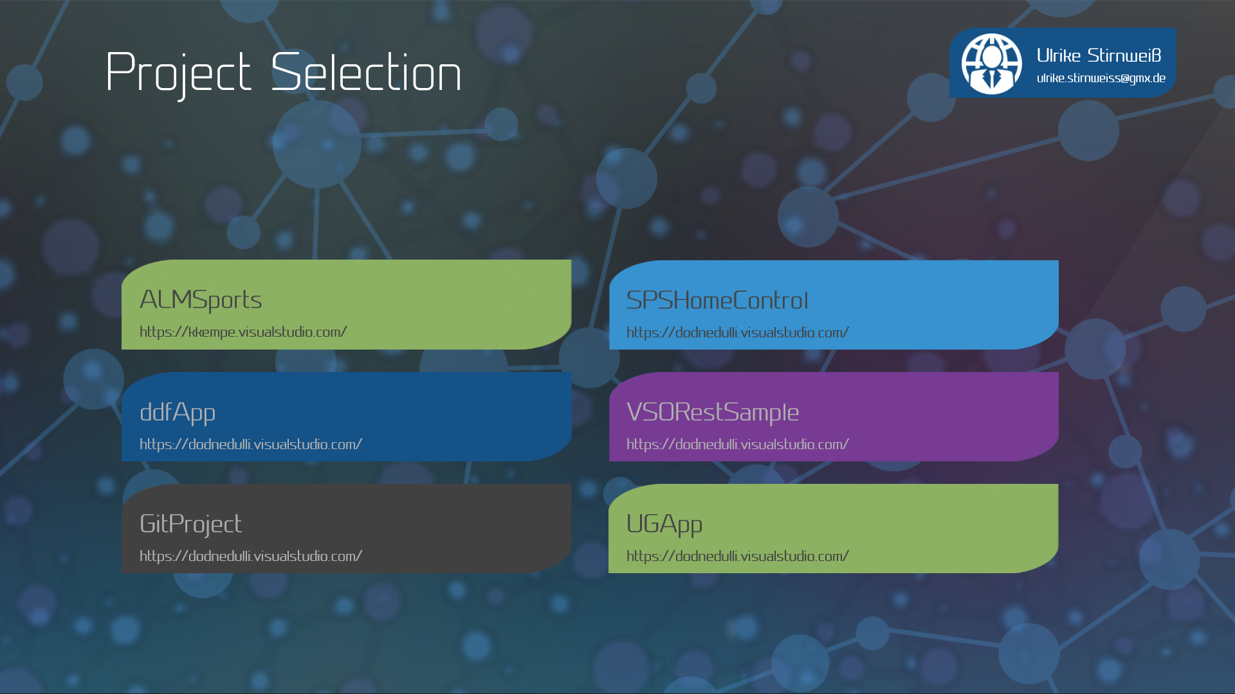

As the app only supports projects that use a Scrum Template all other projects are greyed out and are not clickable. To proceed with the app simply click on the team project you want to use. On the following screen select what you want to do. 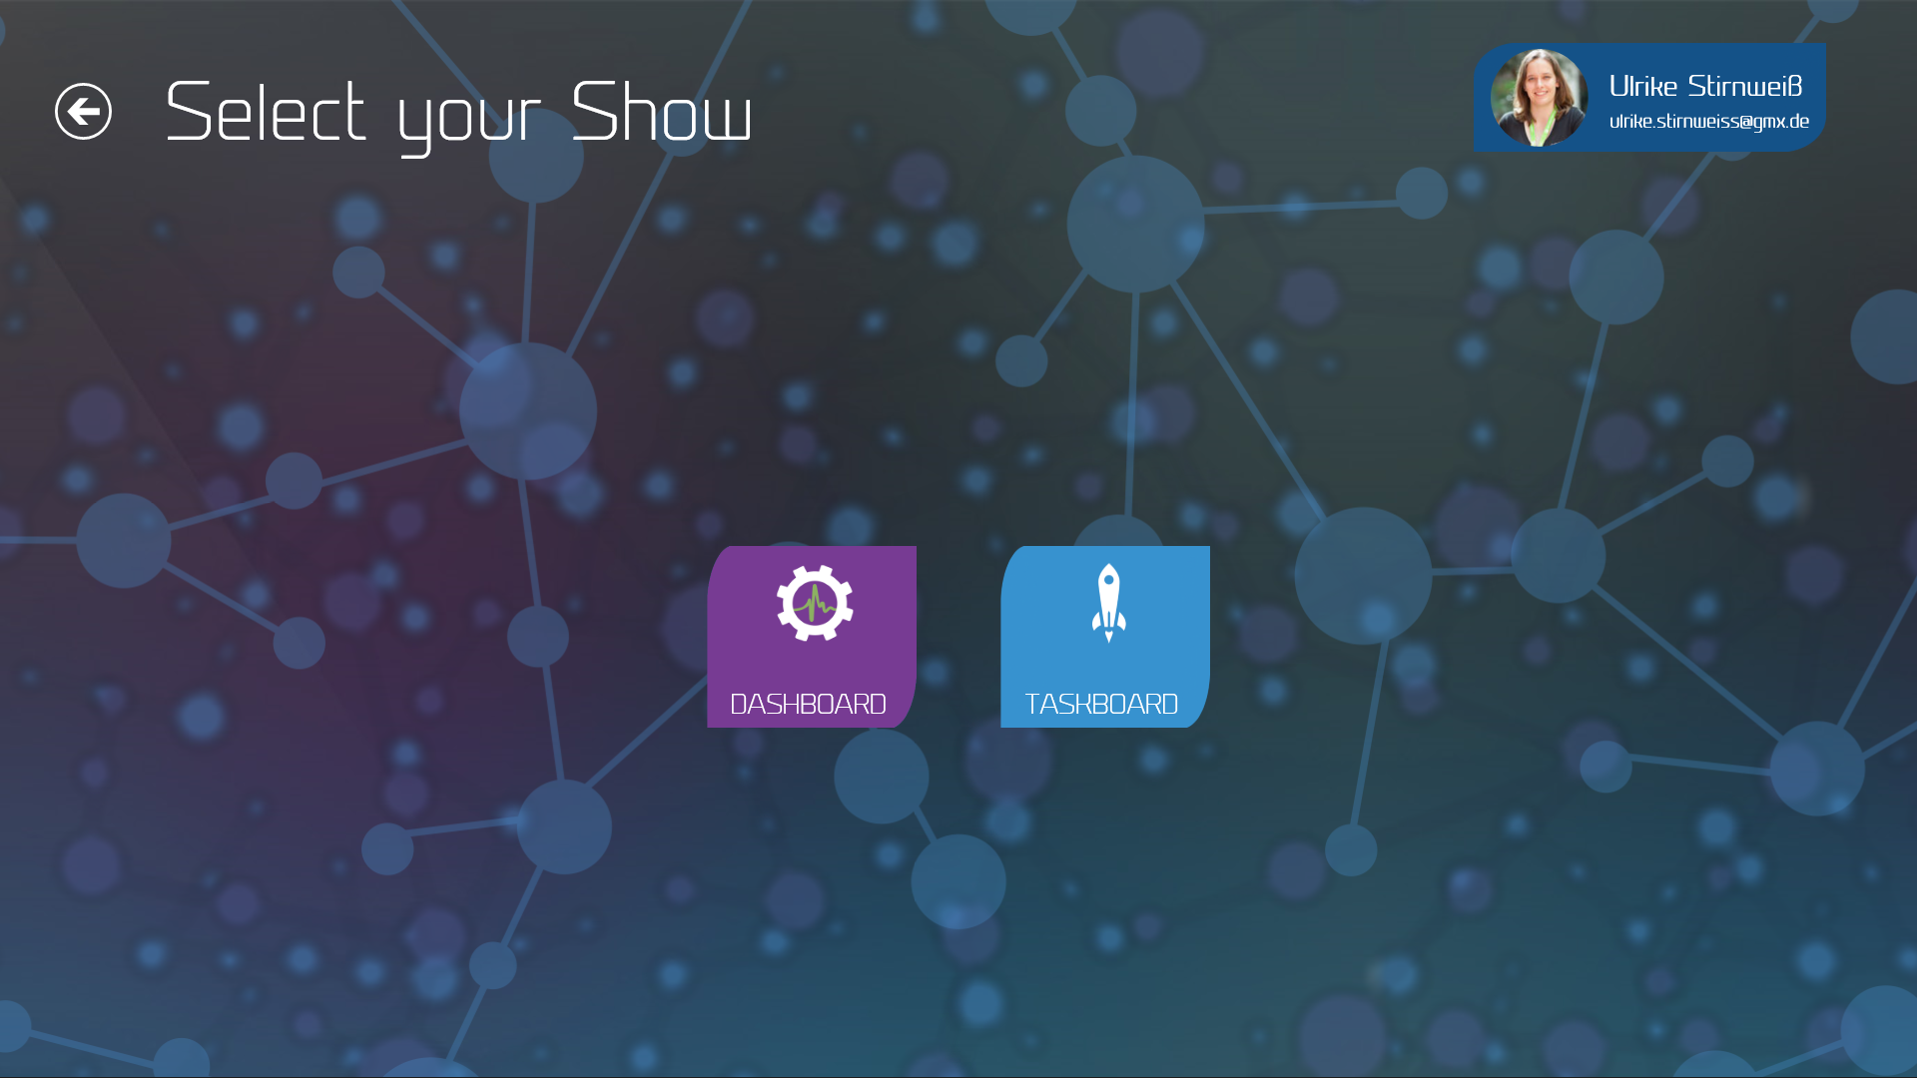

## **Dashboard**

The Dashboard shows four different information:

* current burndown chart in the lower right
* latest builds in the upper right
* latest checkins in the upper right
* current sprint information on the left side

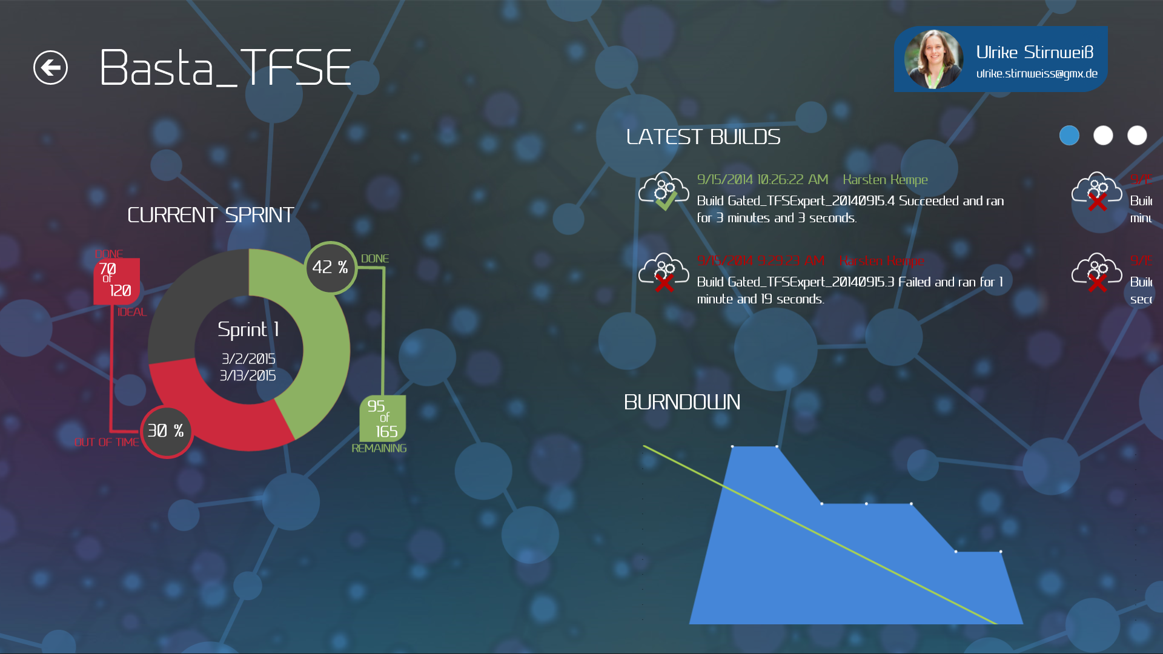

The checkin information is only available if you use TFS as your source control and not Git. The upper right corner switches between builds and checkins periodically, but you can switch it with the white circles by yourself.

The sprint information shows the name of the sprint as well as start and end date of it. The donut around this information displays in green how much work is already done, in red the delay what should have been done till now to be “in time” and in gray the rest of the sprint work. In the box at the right you see how much work in hours is remaining. The left box displays the ratio between the work hours done and the ideal work hours that should have been done till now. The left side indicates with green and red if you are in or out of time.

### Update

The dashboard will be automatically updated if somebody changes something if you have configured a service hook for your project. To manually refresh the data you can use the refresh button in the command bar.

### Switch team

When you right click on the dashboard or swipe from the upper screen border you can navigate between the different teams inside your team project. Initially the dashboard shows the data from the default team.

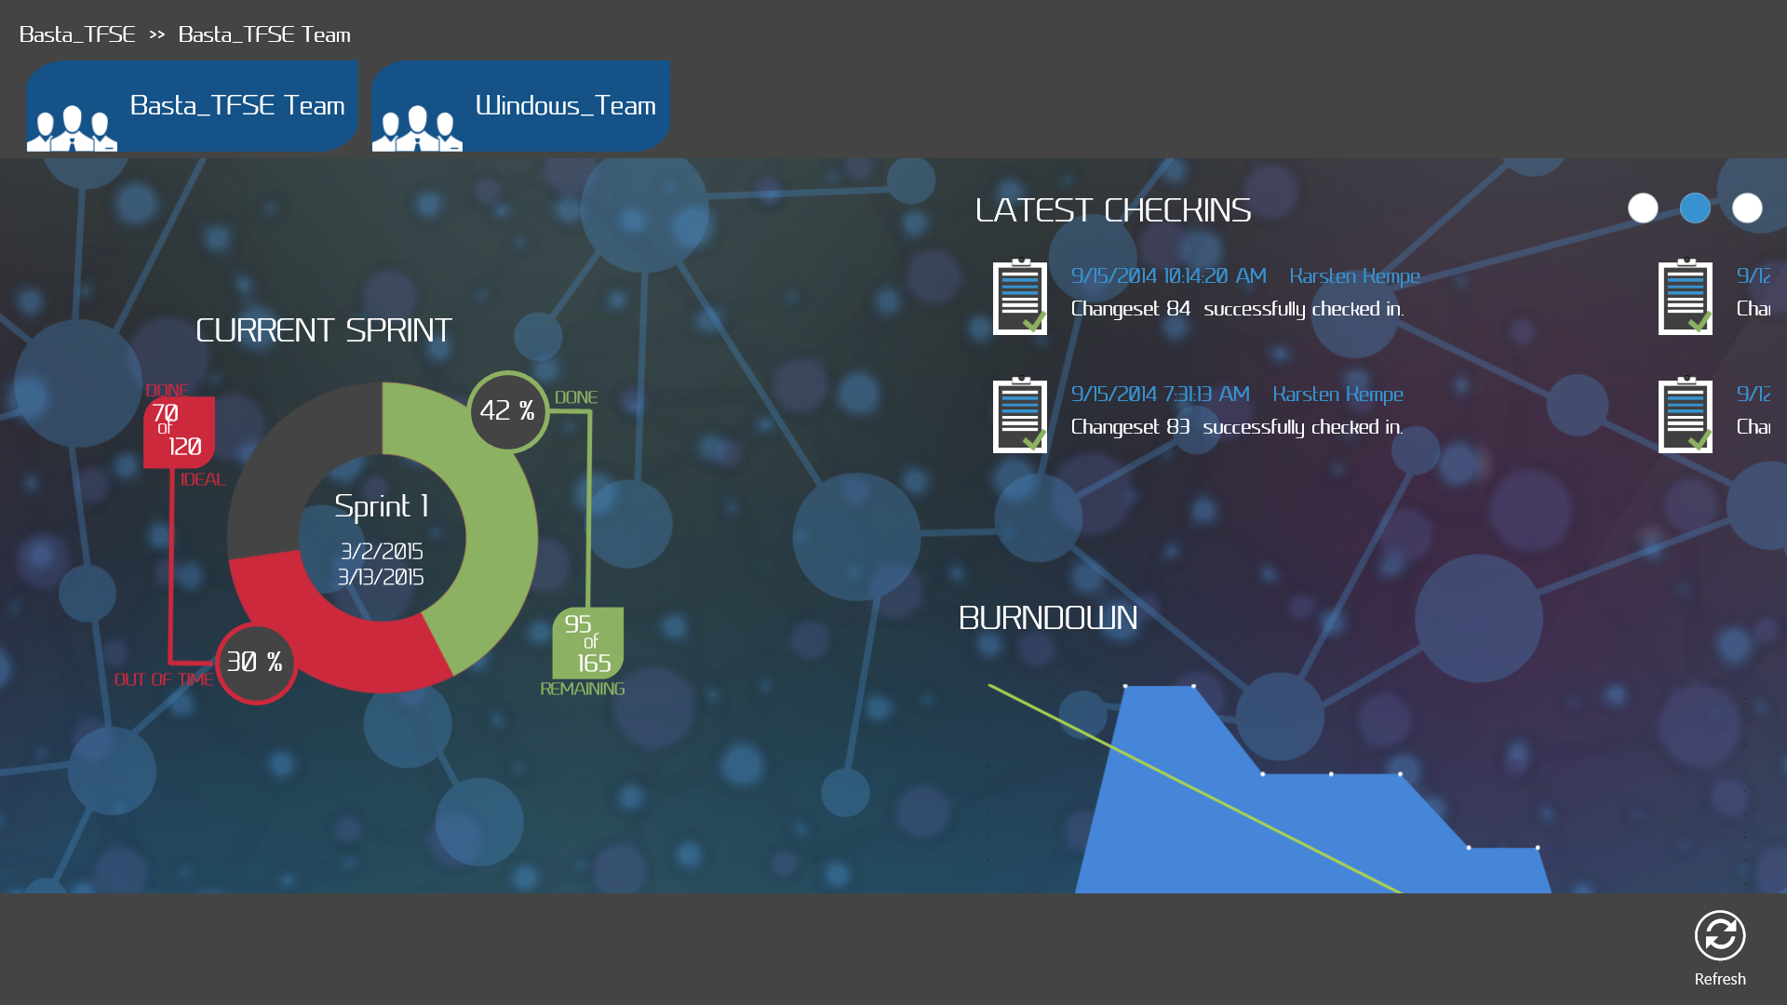

## **Taskboard**

The taskboard displays all work that is scheduled for the current sprint. Each line represents one PBI/Bug with its corresponding tasks (yellow circles). Each task displays its assignee with name and picture, the id and title of the task as well as the remaining work for the task. The size of the circles depends on the amount of work that left for the task.

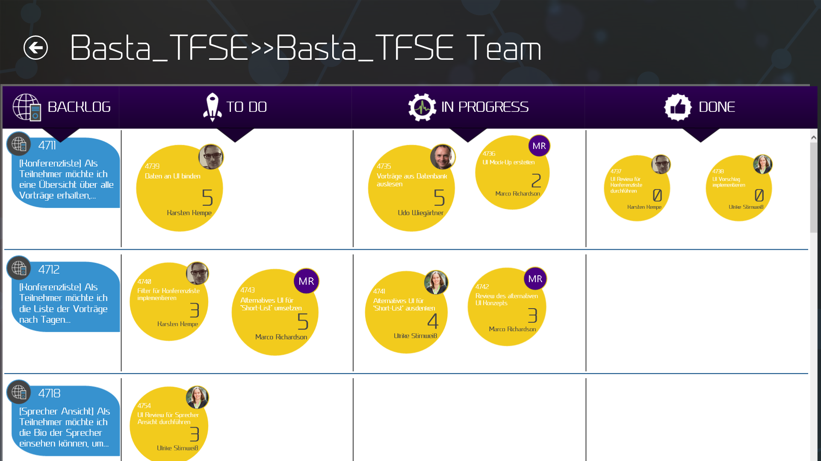

### Semantic zoom

When you zoom out you get a view of all PBIs and Bugs and can easily navigate to a specific PBI/Bug. You also easily see in this view how many tasks of the PBI/Bug are to do, in progress or done. PBIs are visualized in blue and bugs are visualized in red.

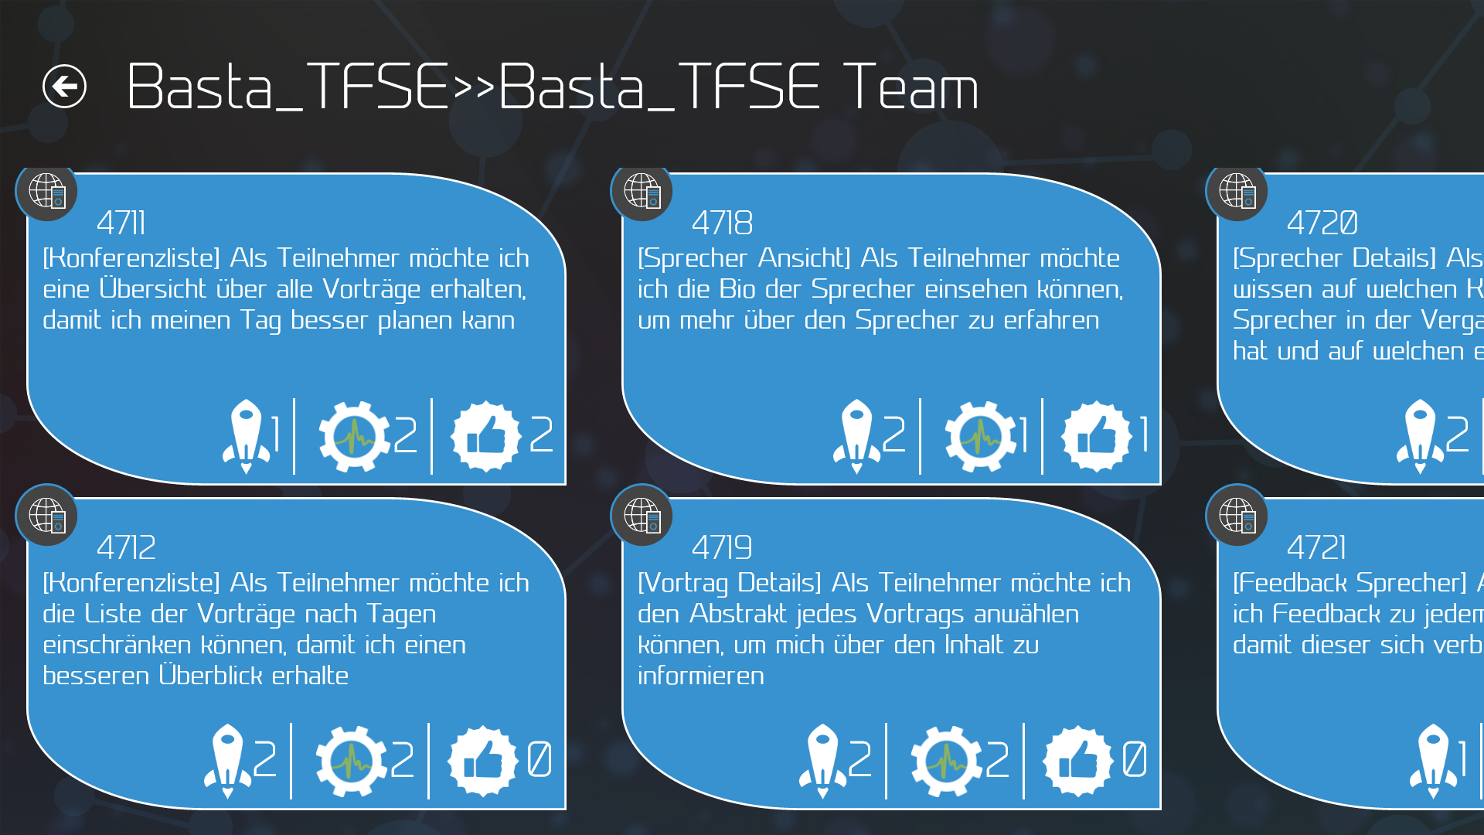

### Change tasks

By tapping on a task in the taskboard you see the description of the task and you are able to change the assignee and adapt the remaining work.

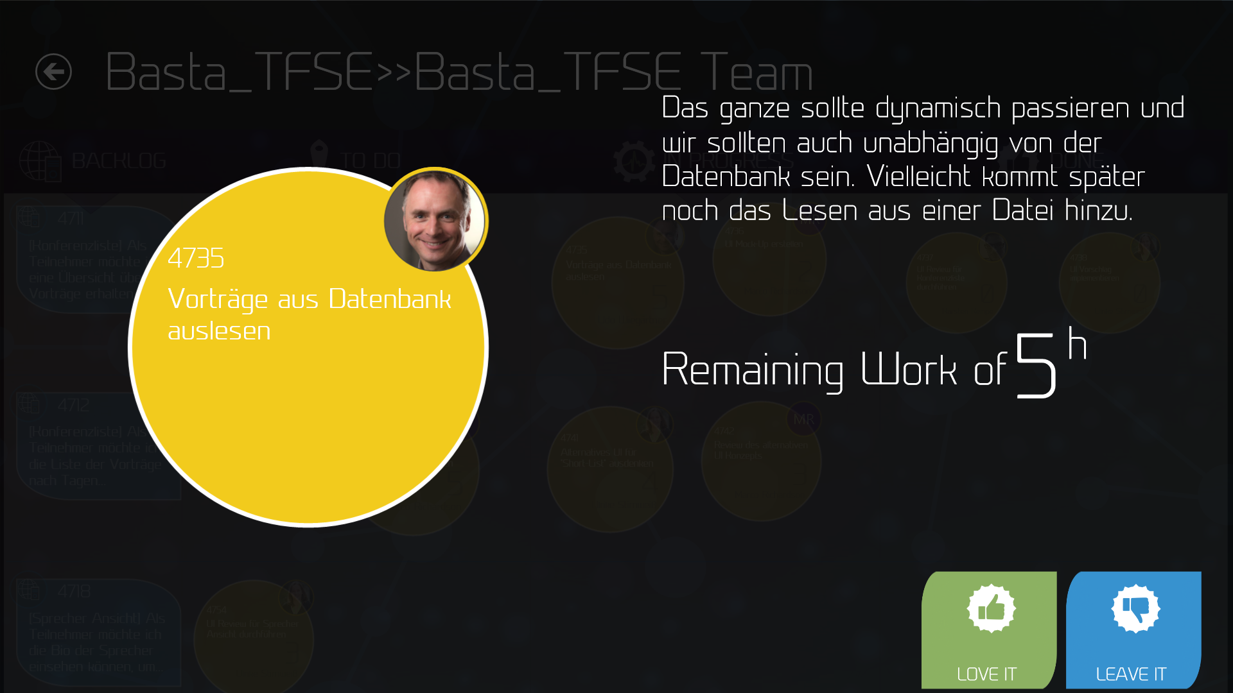

The assignee can be changed by tapping on the image of the current assignee. A list of all available persons in the team project is shown and you can select the new one.

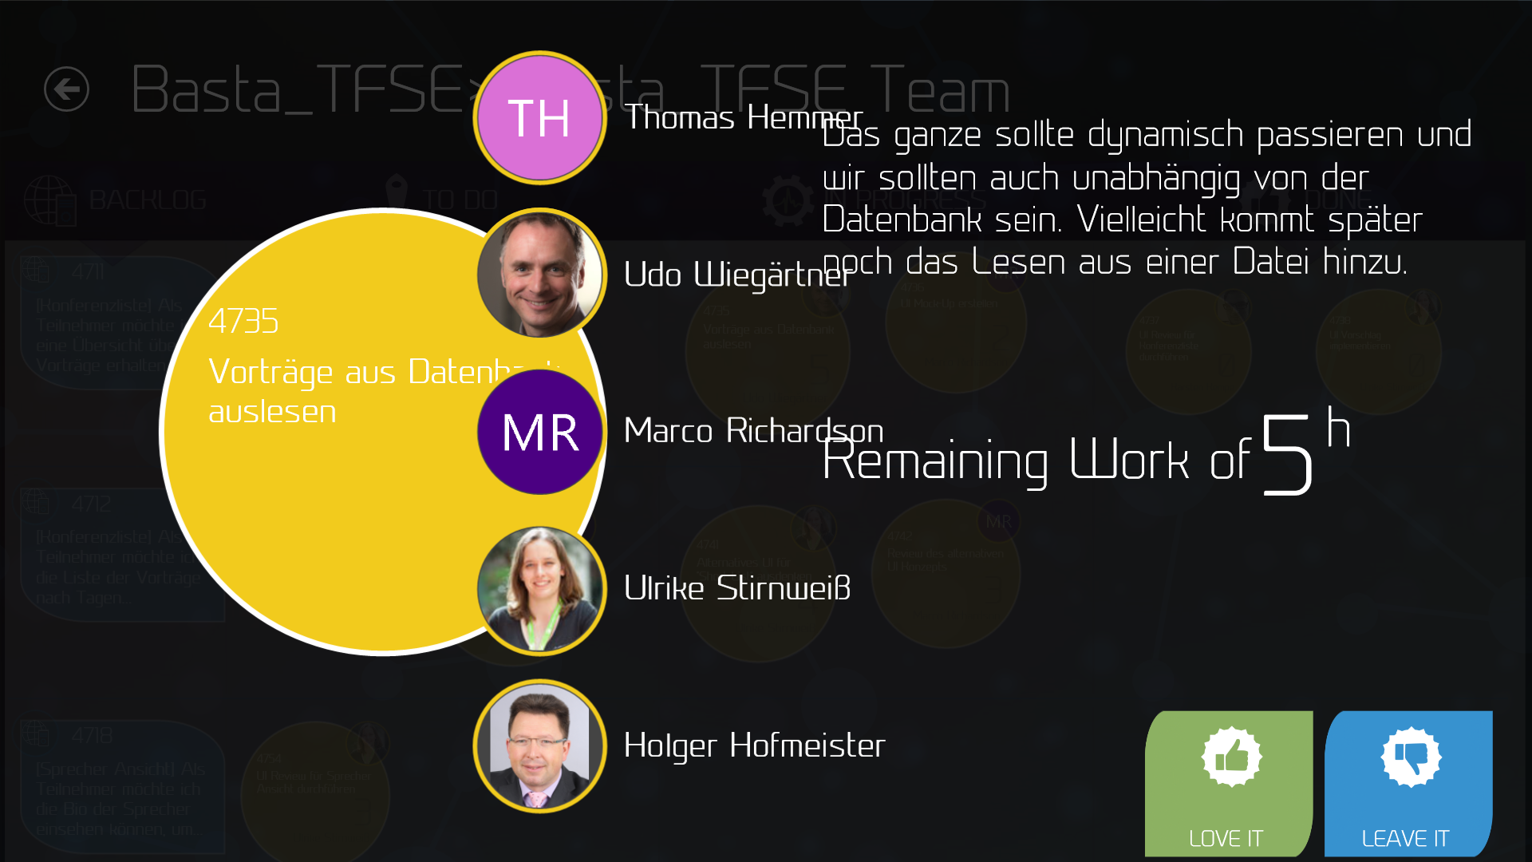

The remaining work can be changed by rotating the task circle. Just simply put three of your fingers on the yellow circle and try to rotate the circle like you would do with a mechanical combination lock of a safe. Rotating left will decrease the remaining work and right will increase it. In both cases you see the on the right the impact of your change on the sprint status.

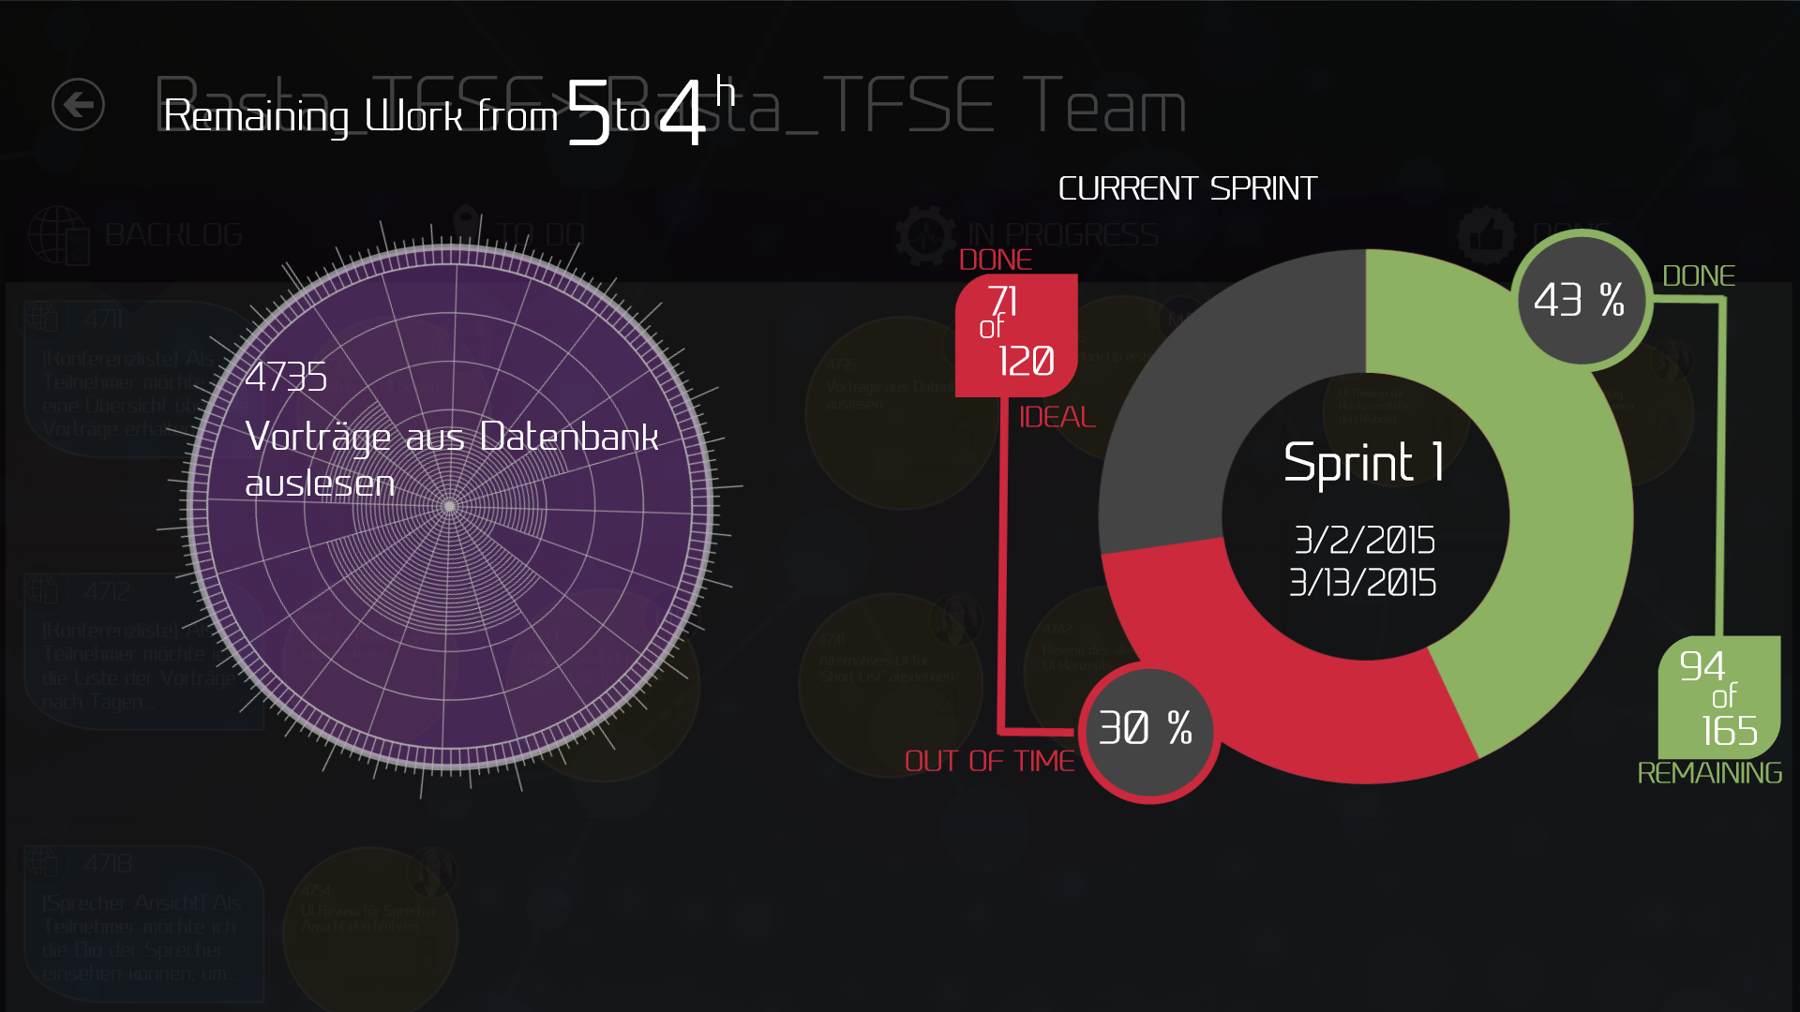

By lifting your fingers from the screen the normal screen will be shown again and you can now submit or cancel you changes with the two buttons in the left lower corner.

### Update

The taskboard will be automatically updated if somebody changes something if you have configured a service hook for your project. To manually refresh the data you can use the refresh button in the command bar.

### Switch team

Initially the dashboard shows the data from the default team. You can see which team is chosen in the headline of the taskboard.

When you right click on the taskboard or swipe from the upper screen border you can navigate between the different teams inside your team project.

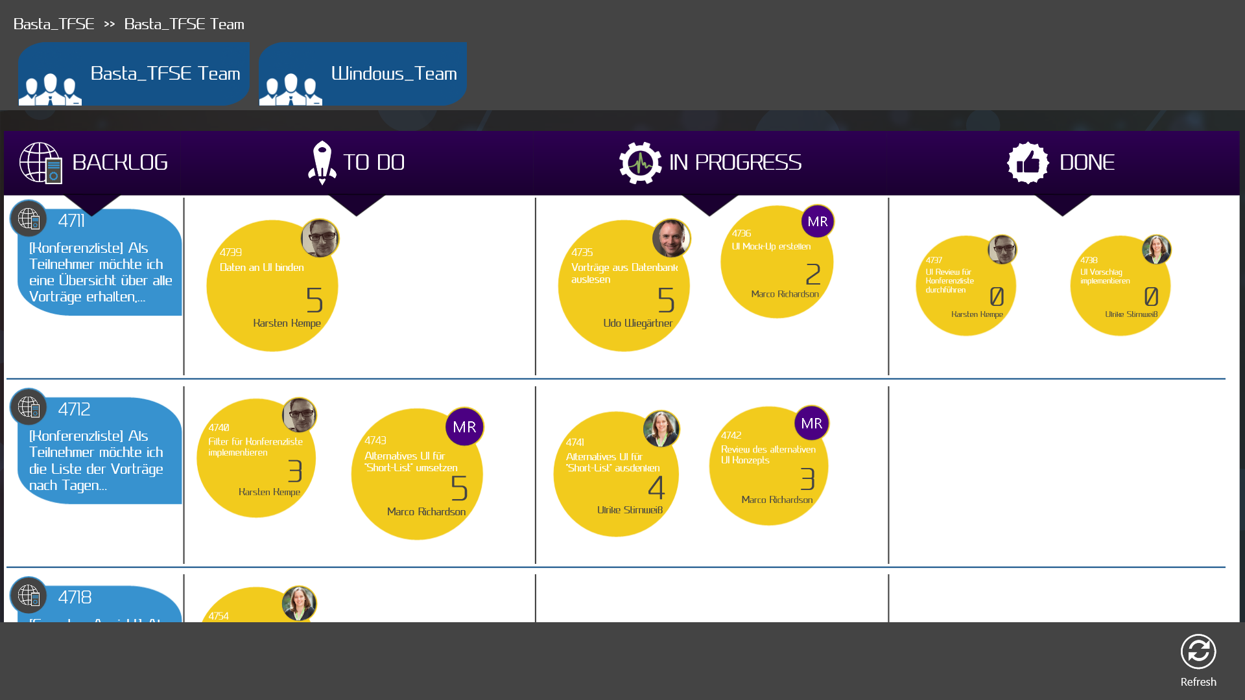

## **Settings**

The settings menu has to parts where you can change something.

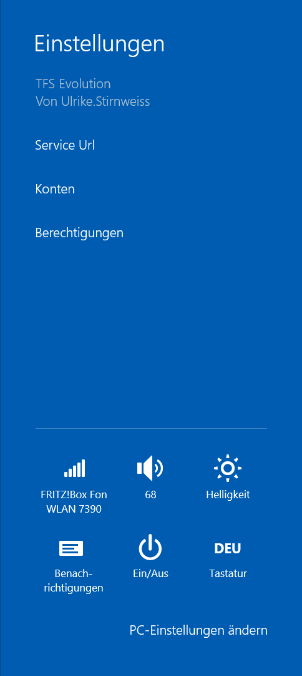

### Change custom web service

The settings item “Service Url” is used to change the custom web service. Predefined the app uses the web service that is hosted by complement AG to get the additional information about the team project and this web service is also used by the service hook to update the app on changes.

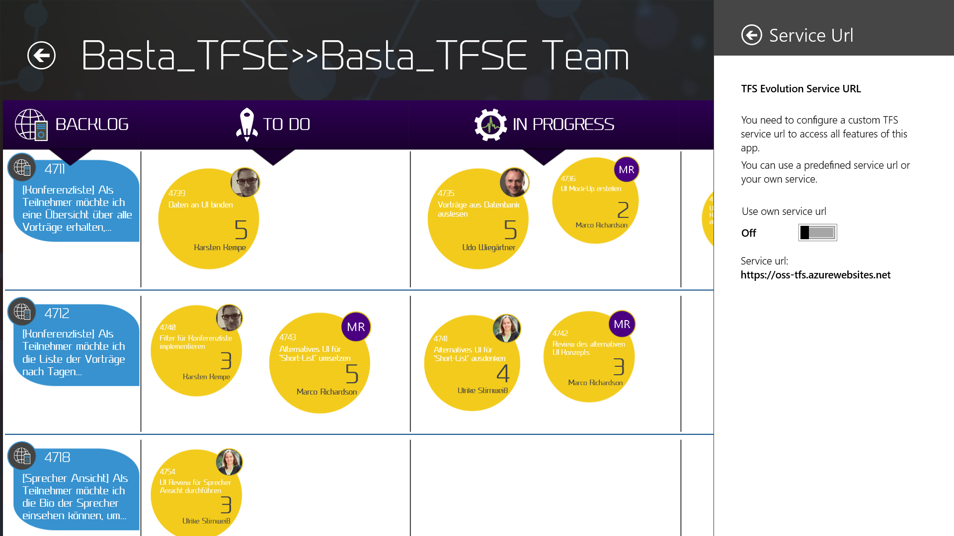

If you want to use your own web service you need to switch this option to “on” and enter the URL of your service (Note: Enter without https:// abbreviation).

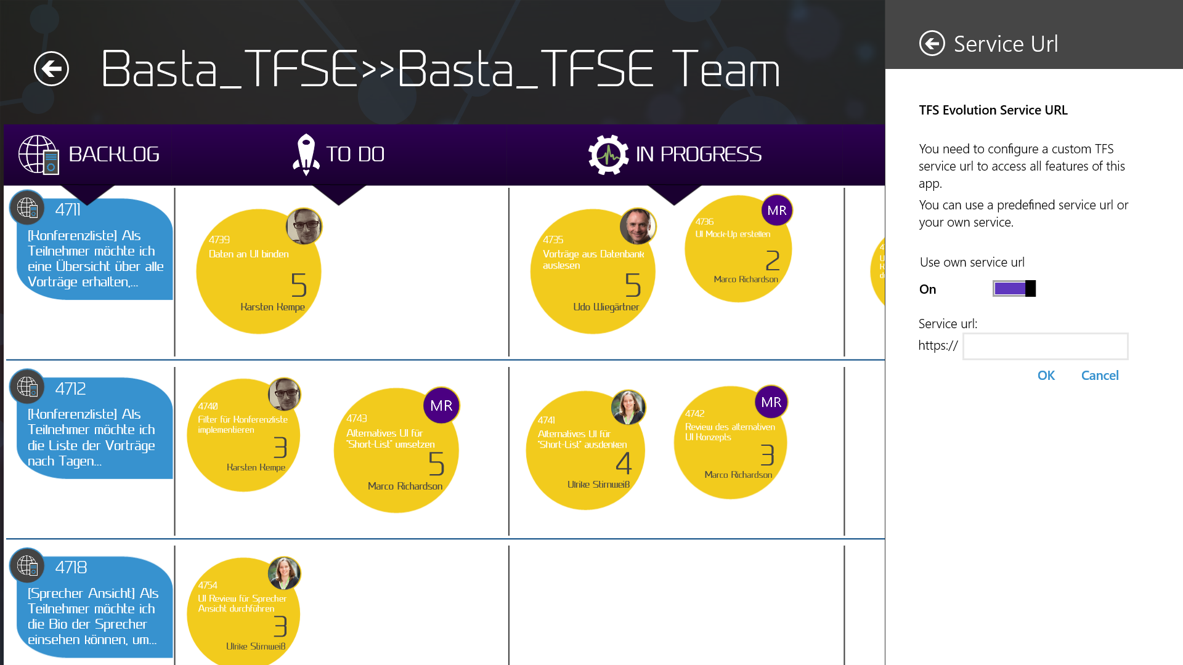

Switching the toggle option to “off” again will lead to using the default web service again.

### Remove alternative credentials

If you have entered wrong credentials or need to change them. You can delete the saved credentials with the “accounts” setting item. Just simply click on the saved credentials and delete them. Afterwards you are asked to enter your alternative credentials again.